**CHAPTER 4**

**SYSTEM SPECIFICATION**

**Software Requirements:**

Operating System : Windows OS

Programming Language : Python 3.11

Installation Software : Python 3.11

Platform : Visual Studio Code

**Hardware Requirements:**

System Specification : Intel i5

Clock speed : 3.0 GHz

Ram Size : 512 M

Hard disk capacity : 40 GB

Sensors : DSB18B20 Temperature sensor, pH Sensor

Turbidity Sensor

Arduino UNO

ESP8266 Microcontroller

16*2 LCD Display

**4.1 Python:**

**4.1.1 Introduction:**

Python is a widely used general-purpose, high level programming language. It was created by Guido van Rossum in 1991 and further developed by the Python Software Foundation. It was designed with an emphasis on code readability, and its syntax allows programmers to express their concepts in fewer lines of code.

Python works on different platforms (Windows, Mac, Linux, Raspberry Pi, etc). Python has a simple syntax similar to the English language. Python has syntax that allows developers to write programs with fewer lines than some other programming languages. Python runs on an interpreter system, meaning that code can be executed as soon as it is written. This means that prototyping can be very quick. Python can be treated in a procedural way, an object-oriented way or a functional way.

Python was designed for readability, and has some similarities to the English language with influence from mathematics. Python uses new lines to complete a command, as opposed to other programming languages which often use semicolons or parentheses. Python relies on indentation, using whitespace, to define scope; such as the scope of loops, functions and classes. Other programming languages often use curly-brackets for this purpose.

**4.1.2 Python Library:**

A Python library is a collection of related modules. It contains bundles of code that can be used repeatedly in different programs. It makes Python Programming simpler and convenient for the programmer. As we don't need to write the same code A Python library is a collection of related modules. It contains bundles of code that can be used repeatedly in different programs. It makes Python Programming simpler and convenient for the programmer. As we don't need to write the same code again and again for different programs. Python libraries play a very vital role in fields of Machine Learning, Data Science, Data Visualization, etc.

**4.1.3 Working of Python Library:**

A Python library is simply a collection of codes or modules of codes that we can use in a program for specific operations. We use libraries so that we don’t need to write the code again in our program that is already available. But how it works. Actually, in the MS Windows environment, the library files have a DLL extension (Dynamic Load Libraries). When we link a library with our program and run that program, the linker automatically searches for that library. It extracts the functionalities of that library and interprets the program accordingly. That’s how we use the methods of a library in our program. We will see further, how we bring in the libraries in our Python programs.

**4.1.4 Python Standard Library:**

The Python Standard Library contains the exact syntax, semantics, and tokens of Python. It contains built-in modules that provide access to basic system functionality like I/O and some other core modules. Most of the Python Libraries are written in the C programming language. The Python standard library consists of more than 200 core modules. All these works together to make Python a high-level programming language. Python Standard Library plays a very important role. Without it, the programmers can’t have access to the functionalities of Python. But other than this, there are several other libraries in Python that make a programmer’s life easier. Let’s have a look at some of the commonly used libraries:

**Matplotlib:** This library is responsible for plotting numerical data. And that’s why it is used in data analysis. It is also an open-source library and plots high-defined figures like pie charts, histograms, scatterplots, graphs, etc.

**Pandas:** Pandas are an important library for data scientists. It is an open-source machine learning library that provides flexible high-level data structures and a variety of analysis tools. It eases data analysis, data manipulation, and cleaning of data. Pandas support operations like Sorting, Re-indexing, Iteration, Concatenation, Conversion of data, Visualizations, Aggregations, etc.

**Numpy:** The name “Numpy” stands for “Numerical Python”. It is the commonly used library. It is a popular machine learning library that supports large matrices and multi-dimensional data. It consists of in-built mathematical functions for easy computations. Even libraries like TensorFlow use Numpy internally to perform several operations on tensors. Array Interface is one of the key features of this library.

**SciPy:** The name “SciPy” stands for “Scientific Python”. It is an open-source library used for high-level scientific computations. This library is built over an extension of Numpy. It works with Numpy to handle complex computations. While Numpy allows sorting and indexing of array data, the numerical data code is stored in SciPy. It is also widely used by application developers and engineers.

**Scikit-learn:** Scikit-learn is a popular open-source Python library for machine learning, built on top of the NumPy and SciPy libraries. It provides a wide range of machine learning algorithms and tools for tasks such as classification, regression, clustering, and dimensionality reduction, as well as tools for model selection and evaluation. Scikit-learn is known for its ease of use, with a consistent API and comprehensive documentation, making it accessible for both beginners and experienced machine learning practitioners. It also offers a range of features for data pre-processing, feature engineering, and model tuning, making it a powerful tool for building end-to-end machine learning pipelines. Scikit-learn is widely used in industry and academia for a variety of applications, and its large community ensures that it is continually evolving and improving.

**XG Boost:** XGBoost is a popular open-source Python library for gradient boosting that has gained widespread popularity in recent years due to its high performance and scalability. Gradient boosting is a machine learning technique that combines the predictions of multiple weak models to improve accuracy, and XGBoost is a powerful implementation of this technique. It is designed to be fast and efficient, making it ideal for working with large datasets and high-dimensional feature spaces. XGBoost offers a range of features for model training, including early stopping, cross-validation, and regularization, and it can be used for a variety of machine learning tasks, including classification, regression, and ranking. Its popularity has led to its use in many industry applications, including search engines, recommendation systems, and fraud detection. XGBoost is a valuable tool for any data scientist or machine learning practitioner looking to improve their model performance and accuracy.

**Flask:** Flask is a popular open-source Python web framework that is used for developing web applications. It is known for its simplicity, flexibility, and lightweight design, making it an ideal choice for small to medium-sized applications. Flask is built on top of the WSGI toolkit and provides a range of features for building web applications, including URL routing, request handling, and template rendering. Flask is also highly customizable, allowing developers to choose their own libraries and tools for building their applications. It is widely used in industry and has a large and active community, with many third-party extensions and plugins available to extend its functionality. Flask is a valuable tool for anyone looking to build a Python-based web application, whether for personal or professional use.

**4.2 Hardware Components**

**4.2.1 DS18B20 temperature sensor:**

The DS18B20 is a digital temperature sensor that can measure temperatures ranging from -55°C to 125°C with an accuracy of ±0.5°C. It uses a one-wire interface, which means that multiple sensors can be connected to a single data line, making it easy to monitor temperature in different locations. Additionally, the DS18B20 has a unique 64-bit serial code that can be used to identify individual sensors in a network. This sensor is commonly used in a wide range of applications such as environmental monitoring, HVAC systems, and industrial automation, among others. It is a digital temperature sensor that uses a 1-Wire communication interface. This means that it can be connected to a microcontroller or computer using just one wire for data transfer and ground connection. The sensor has a resolution of 9 to 12 bits, which means that it can detect temperature changes as small as 0. 0625°C.It has a wide operating voltage range of 3.0V to 5.5V, making it suitable for use with a variety of microcontrollers and other electronics. This sensor has a variety of applications including industrial temperature monitoring, HVAC systems, weather stations, and home automation systems, among others. It has a waterproof variant which is ideal for use in outdoor applications where the sensor may be exposed to moisture. The sensor can be powered using parasitic power, which means that it can draw power from the data line, eliminating the need for an external power supply.

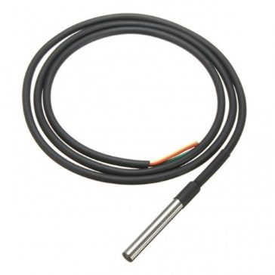

Fig

**4.2.2 Arduino UNO:**

The Arduino UNO is a small and affordable microcontroller board that is commonly used for prototyping and DIY electronics projects. It has a variety of input and output pins that can be used to connect sensors, LEDs, motors, and other electronic components. The board is also compatible with a wide range of shields, which are add-on boards that can provide additional functionality such as wireless communication, motor control, or LCD displays.

The board is powered by either a USB cable or an external power supply and can communicate with a computer or other devices through its USB port. The board also includes a reset button that can be used to restart the program running on the microcontroller. The Arduino UNO is programmed using the Arduino IDE, which is a software development environment that is free and open-source. The IDE includes a code editor, compiler, and uploader, making it easy to write, test, and upload code to the board.

The Arduino UNO has a large and active community of users who share their projects and code online. This makes it easy for beginners to find examples and tutorials that can help them get started with the board. Additionally, the board is often used in educational settings to teach programming and electronics, and there are many resources available for teachers and students. Overall, the Arduino UNO is a powerful and versatile tool that can be used for a wide range of projects and applications.

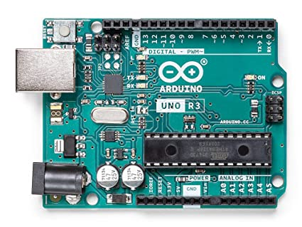

Fig 2

**4.2.3 pH Sensor:**

pH sensors are commonly used in water quality monitoring applications to measure the acidity or alkalinity of water. pH is a measure of the concentration of hydrogen ions in a solution, and it is expressed on a scale of 0 to 14, with 7 being neutral, values below 7 indicating acidity, and values above 7 indicating alkalinity.

Water with a pH level outside of the range of 6.5 to 8.5 can be harmful for human consumption and can affect the performance of water treatment systems. pH sensors for water quality monitoring are typically designed to be submerged in water and can measure pH levels with high accuracy and repeatability.

The sensors can be integrated into water quality monitoring systems, which can measure pH levels continuously and provide real-time data to operators. This data can be used to identify changes in water quality, detect potential problems in water treatment systems, and monitor the effectiveness of treatment processes.

Overall, pH sensors are an essential component of water quality monitoring systems and play a crucial role in ensuring the safety and sustainability of our water resources.

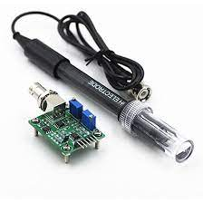

**Fig 3**

**4.2.4 Turbidity Sensor:**

Turbidity sensors are used to measure the number of suspended particles in water or other fluids. Turbidity is a measure of the cloudiness or haziness of a fluid, caused by the presence of particles such as sediment, algae, or organic matter. Turbidity can be an important indicator of water quality, as high levels of turbidity can indicate the presence of pollutants or other contaminants in the water. Turbidity sensors work by shining light through the fluid and measuring the amount of light that is scattered or absorbed by the particles. The sensors can be integrated into water quality monitoring systems and can provide continuous measurement of turbidity levels in real-time.

Turbidity sensors are commonly used in a variety of applications, including drinking water treatment, wastewater treatment, aquaculture, and environmental monitoring. They can also be used in research and development applications, such as in the study of sediment transport in rivers and estuaries.

Overall, turbidity sensors are an important tool for water quality monitoring and can help to ensure the safety and sustainability of our water resources.

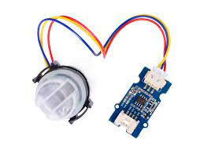

Fig 4

**4.2.5 ESP266 Micro Controller:**

The ESP8266 is a low-cost, highly-integrated Wi-Fi microcontroller designed for Internet of Things (IoT) applications. It is based on the Ten silica L106 32-bit microcontroller and features built-in Wi-Fi connectivity, making it ideal for applications that require wireless connectivity. The ESP8266 also includes a range of input/output (I/O) pins, allowing it to be used with a wide range of sensors, actuators, and other electronic components.

The ESP8266 is often used as a standalone microcontroller or as a Wi-Fi module for other microcontroller boards such as the Arduino. It can be programmed using a variety of programming languages and environments, including C++, Lua, and the Arduino IDE.

The ESP8266 is known for its low power consumption and small form factor, making it ideal for battery-powered or space-constrained applications. It also supports a range of communication protocols, including HTTP, MQTT, and TCP/IP, making it easy to integrate into existing IoT ecosystems.

Overall, the ESP8266 is a powerful and versatile microcontroller that has become a popular choice for IoT applications. Its low cost, built-in Wi-Fi connectivity, and range of I/O pins make it an attractive option for a wide range of projects and applications.

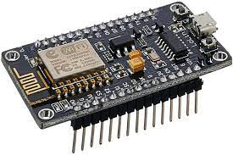

Fig 5